T-H13
Horizontal Machining Center
Technology Agreement

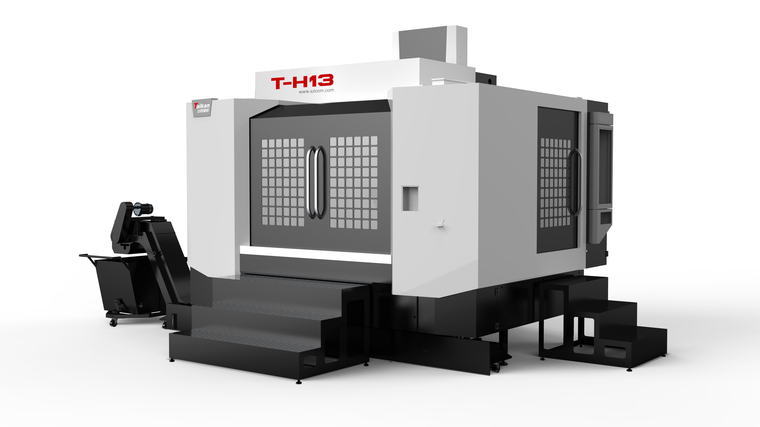
(This figure is for reference only)
- Technical description of equipment
- Technical description of equipment structure
T-H13 is a medium-to-large-sized horizontal machining center. This machine is widely used in the processing of medium-to-large-sized boxes, valves, shells, plates and other complex parts in the automotive, mold, machinery manufacturing and other industries. The parts can be automatically processed by milling, drilling, boring, expanding, reaming, countersinking, tapping and other processes on four faces in one clamping. The machine uses high-precision linear rails and lead screws, and the machine has better dynamic responsiveness and can achieve high-precision processing.
- The whole machine structure adopts a fixed column and cross slide table design. The machine is equipped with an oversized and stable base, high-rigidity large-span herringbone columns, ensuring no vibration or deformation during high-speed cutting.
- The main components are all cast from high-quality resin sand molding and high-strength cast iron material, providing the machine tool with high rigidity and stable accuracy.
- The XZ axis guide rails are loaded with 45# roller linear rails, the Y axis is loaded with 55# roller linear rails, and the Z axis is designed with four guide rails. It has strong load-bearing capacity and good seismic resistance.
- The C3-grade lead screw is equipped with a pre-tension structure to eliminate partial thermal expansion. The lead screw bearing adopts self-lubrication to extend the bearing life.
- The tool magazine adopts Taikan's 24-arm tool magazine, which is reliable in quality and stable in performance;
- The spindle adopts Taikan's high-speed spindle unit, with a BT50-6000r/min belt head. The front end of the spindle employs a labyrinth design, and the spindle has an air curtain protection function to prevent cutting fluid from entering the spindle bearing.
- Equipped with a volumetric and forced lubrication oil system to ensure good lubrication of all moving parts of the entire machine tool.
- The machine tool adopts spiral chip conveyor and front water tank design, which is user-friendly and efficient. The double-layer water tank filtration system provides excellent cutting fluid for workpiece processing.
- Equipped with a high-performance FANUC CNC system, it ensures the stability of machine tool control as well as the CNC machining and auxiliary functions required by users.
- Working Conditions:
- Three-phase AC power supply: 380V±5%; 50Hz±1Hz. The main power cord should be 10mm² or larger, and the grounding wire should be 10mm² or larger.
- Ambient temperature: It is necessary to maintain the ambient temperature between 17~25℃. If the precision requirements for the processed parts are not high, it can be relaxed to 5~40℃. Storage or transportation temperature should be -20~60℃.
- Temperature change in the room: The surrounding temperature change should be within ±2℃ within 24 hours.
- Relative humidity: Less than 75% (without condensation).
- Altitude: Below 1000m
- Vibration: Below 0.2G
- Foundation requirements: Bearing capacity above 50KN/m²
- Keep away from light sources, vibration sources and heat sources. Also avoid being close to high-frequency motors, discharge motors, electric welding machines, etc., to prevent electrical interference from causing malfunctions in the machine tool's NC system.
- Equipment Parameters and Configurations
2.1 Equipment Parameters
Name |  |  | Unit | Parameter | Remark
Travel range | Worktable Travel e (X-axis) |  | mm | 1350 | Left to right
Travel range | Ram Travel (Z-axis) |  | mm | 750 | Front to back
Travel range | Spindle Box Travel (Y-axis) |  | mm | 850 | Up and down
Travel range | Distance from spindle end face to table center |  | mm | 90～840
Travel range | Distance from the spindle center to the worktable surface. |  | mm | 50～900
Travel range | Maximum workpiece rotation diameter |  | mm | 1450
Travel range | Maximum allowable height of workpiece |  | mm | 950 | from the start of the workbench
worktable | Size |  | mm | 630*630
worktable | Load bearing |  | kg | 1200
worktable | T-slot (Number of slots - Slot width * Spacing) |  | mm | 5-18*100
worktable | Center positioning hole |  | mm | Φ50H7
worktable | Division accuracy |  | arc.sec | 8
worktable | Repeatability accuracy |  | arc.sec | 2
worktable | Locking pressure |  | kg/cm2 | 27250
worktable | Maximum rotational speed |  | rpm | 11.1
worktable | Minimum division unit |  | Deg(°) | 1°
Spindle | Motor power (rated/short-time) |  | kW | 15/18.5
Spindle | Motor torque (rated/short-time) |  | N.m | 143/191
Spindle | Speed range |  | r/min | 6000（皮带）
Spindle | Spindle diameter |  | mm | φ190
Spindle | Spindle reduction ratio |  |  | 4∶3
Spindle | Handle Specifications |  |  | BT50
Spindle | Pull stud specification |  |  | P50T-I（MAS403）
Guide rails | X-axis |  | mm | 2-45 roller
Guide rails | Y-axis |  | mm | 2-55 roller
Guide rails | Z-axis |  | mm | 2-45 roller
Driven | Ball screw X/Y/Z |  | mm | X/Z:50/12;Y:50/10
Driven | Motor power X/Y/Z/B |  | kW | 3/3/3/2.5
Speed | Range of cutting feed speed |  | mm/min | 1-10
Speed | Rapid traverse speed of X, Y, Z axes |  | m/min | 20/20/20
Accuracy | Positioning accuracy (X/Y/Z) |  | mm | 0.012 | GB/T 18400.4 (Full travel)
Accuracy | Repeat positioning accuracy (X/Y/Z) |  | mm | 0.008 | GB/T 18400.4 (Full travel)
Tool magazine | Magazine capacity |  | T | 24
Tool magazine | Tool length |  | kg | 15
Tool magazine | Tool length |  | mm | 400
Tool magazine | Max. Diameter (full/ adjacent) |  | mm | Φ110/Φ200
others | CNC system |  |  | Fanuc-0i-MF(5)
others | Gas sour | Flow | 500 | 500
others | Gas sour | Air pressure | 0.6∼0.8 | 0.6∼0.8
others | Equipment capacity |  | KVA | 40
others | Coolant Tank Capacity |  | L | 340
others | Machine appearance size |  | mm | 4242×3008×3340 | front to back/ left to right/ up to down
others | Total Weight (Approximately) |  | kg | 11000
#: The overall dimensions of the machine tool are subject to change due to configuration, without further notice.

2.2 Standard Configurations
No. | Name and specification | Quantity | Note
1 | FANUC CNC system | 1 set
2 | Operation panel | 1 set
3 | Pneumatic System | 1 set
4 | Air Gun | 1 set
5 | Main Spindle Oil Cooling | 1 set
6 | Workpiece Cooling System, Automatic Lubrication System | 1 set
7 | Front chain chip conveyor + chip storage trolley | 1 set
8 | Built-in double screw front chip removal | 1 set
9 | Tri-axis Protective Covers | 3 set
10 | Full Protection | 1 set
11 | Front Flushing Chip Removal | 1 set
12 | Hydraulic Station | 1 set
13 | Lighting Device | 1 set
14 | Tri-color warning light | 1 set
15 | Operating pedal | 2 set
16 | Basic Installation Kit | 1 set
17 | Standard Technical Documentation Package Accompanying the Product | 1 set

2.3 Optional Equipment
Serial Number | Name and specifications | select | notes
1
2
3
4
Note: If this configuration is selected, mark √ in the corresponding item box

- Major Component Brands
Main Components
Serial Number | Name and specifications | brand | notes
1 | control system | FANUC 0i-MF Plus(5) | High performance
2 | spindle unit | TAIKAN | High performance
3 | Bearing of three axes | Japan NSK/ Germany FAG | P4 grade
4 | Ball screw of three axes | Taiwan Intime/Hiwin | C3
5 | Main Electrical Components | France Schneider Electric
6 | Roller Linear Guideway | Taiwan Intime/Hiwin
7 | 24T Arm-type Tool Magazine | Taikan
8 | Oil Cooler | Tongfei
9 | Automatic Lubrication Pump | Taiwan Zhenrong
10 | Rotary table | Tokugawa | HH630HT
11 | Servo Motor | FANUC
12 | Main Pneumatic Components | Japan SMC
Note: In case of insufficient supply, alternative products of other brands may be selected for substitution, but the quality and grade shall not be inferior to the specified configuration.

- Recommended Oil and Grease Table (Please refer to this table according to the actual configuration of the equipment)
Lubrication Parts |  | Quantity | Recommended Lubricating Oil |  | Remark
 |  | Quantity | Room temperature 10～40℃ | Room temperature 5~10℃ | Remark
Guide rail screw | Oil lubrication | 2~4L | Guide rail oil 68# | Guide rail oil 32# | 1. Please apply oil before daily work or when a warning appears.  2. Please pay attention to changing the oil in low temperatures.  3. When using canned grease, ensure that the brand of canned grease is consistent with the manufacturer of the lubricator.
Guide rail screw | Grease lubrication | 0.7~0.8L | Lithium-based grease 000#
Main spindle screw cooling machine | Water cooler | 15~35L | BASF G48 antifreeze (no addition of any other media is allowed) |  | 1. Please add antifreeze or oil before daily work or when a warning appears.  2. Please pay attention to changing the oil in low temperatures
Main spindle screw cooling machine | Oil cooler | 20~40L | 10# Changcheng spindle oil | 5# Changcheng spindle oil
Hydraulic Station |  | 25L | Hydraulic Oil HV 32# | Hydraulic Oil HV 20# | 1. Please check before daily work, and replace the oil annually.  2. Please pay attention to changing the oil in low temperatures.
Pressure Boosting Cylinder |  | 0.1~0.2L | Hydraulic Oil 32# | Hydraulic Oil 20# | 1. Please check before daily work and add oil when the oil level in the oil cup is only 1/3 full.  2. Please pay attention to changing the oil in low temperatures.
Cutting Fluid |  | 100~350L | Select the appropriate cutting fluid based on the work piece material and machining conditions (subject to the actual capacity of the on-site oil tank) |  | If the room temperature is below 5℃, please check if there is any icing in the oil tank before starting the machine
Fourth Axis |  | 0.8~1L | Gear Oil 150# | Gear Oil 100# | 1. Please check before daily work, and replace the oil annually.  2. Please pay attention to changing the oil in low temperatures.
Tool Changer System |  | 7L | Gear Oil 100# | 80W-90 Antifreeze Diesel Engine Oil | 1. Please check before daily work, and replace the oil every 2,400 hours of operation or every six months.  2. Please pay attention to changing the oil in low temperatures.

- Installation, Commissioning, and Acceptance
1. The equipment shall meet the shipping conditions, and the customer shall confirm the completion of the "Pre-delivery Preparation Items for Taikan Precision Machinery" before shipment. Shipment will be arranged once the conditions are met.
2. The buyer shall prepare the foundation installation in advance before the equipment arrives at the user's site to avoid significant impact on the machine tool's precision.
3. After the equipment arrives at the user's site, the user shall be responsible for the foundation, unloading, lifting and positioning.
4. Before the commissioning personnel arrive, the user shall be responsible for connecting the power supply and compressed air to the machine tool, but must not turn on the power or supply air. The buyer shall provide auxiliary items for the machine tool, such as coolant, cooling oil, hydraulic oil, guideway oil, lubricating grease, etc.
5. After the machine tool is transported to the buyer, both parties shall conduct an inventory check according to the contract quantity and packing list. After the inventory check is completed, the seller shall proceed with installation and commissioning. Upon completion of commissioning, the customer shall sign and confirm. The packing list and delivery acceptance form shall be made in duplicate, one for the user to keep and the other to be taken back by the service personnel to the company and stored in the equipment archive.

- Others
1. Matters not covered in this agreement shall be resolved through negotiation between the two parties.
2. This agreement is an attachment to the contract, and it will take effect simultaneously with the contract after being signed by both parties.
3. This agreement is made in duplicate, with Party A and Party B each holding one copy.

